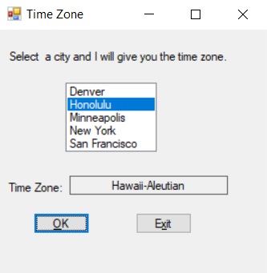

using System;

using System.Collections.Generic;

using System.ComponentModel;

using System.Data;

using System.Drawing;

using System.Linq;

using System.Text;

using System.Threading.Tasks;

using System.Windows.Forms;

namespace Time_Zone

{

public partial class timeZoneForm : Form

{

public timeZoneForm()

{

InitializeComponent();

}

private void exitButton_Click(object sender, EventArgs e)

{

//close the program

this.Close();

}

private void okButton_Click(object sender, EventArgs e)

{

string city; //this is the name of the choice

//-1 to make sure somethign has been selected

if (cityListBox.SelectedIndex !=-1)

{

//get the selected item

city = cityListBox.SelectedItem.ToString();

//figure out the time zone

switch (city)

{

case "Honolulu":

timeZoneLabel.Text = "Hawaii-Aleutian";

break;

case "Denver":

timeZoneLabel.Text = "Mountain";

break;

case "Minneapolis":

timeZoneLabel.Text = "Central";

break;

case "San Francisco":

timeZoneLabel.Text = "Pacific";

break;

case "New York":

timeZoneLabel.Text = "Easter";

break;

}

}

else

{

//in case they hit ok without selecting a city

MessageBox.Show("Select a city first");

}

}

}

}